 

**Bell County Homemaker Newsletter**

**Cooperative Extension Service**

Bell County

101 Courthouse Square

Pineville, Kentucky 40977-1635

(606) 337-2376

Fax: (606) 337-6739

extension.ca.uky.edu

December 2022/January 2023

Our office is open to the public and we are here to serve you! If you are still unsure about venturing out, we can be reached by phone at 337-2376 or by email.

[rebeccaj.miller@uky.edu](mailto:rebeccaj.miller@uky.edu) [brian.good@uky.edu](mailto:brian.good@uky.edu) [aaron.redmond@uky.edu](mailto:aaron.redmond@uky.edu) [michelle.key@uky.edu](mailto:michelle.key@uky.edu) [christy.blevins@uky.edu](mailto:christy.blevins@uky.edu) [tanzi.rader@uky.edu](mailto:tanzi.rader@uky.edu)

If you need anything just let us know. Continue to stay safe and healthy.

**Quote of the Month**



**One kind word can warm three winter months.**

**Japanese Proverb**

Homemaker Cookbooks Now On Sale

Homemade with Love Cookbooks are now on sale at the Extension Office. Cookbooks are

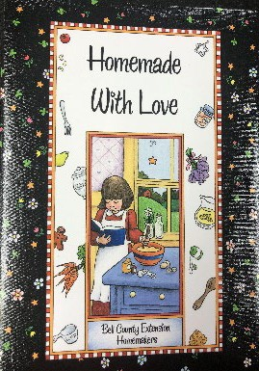$15 and would make a wonderful gift.

Tasty Tuesday

Recipe Swap

Tired of making the same old dishes for the Holidays? Then come on Thursday, December 15th at 1:00 with your favorite recipe to share with others. We will talk about food safety and try out the recipes. We will meet in the third floor meeting room of the courthouse. Call the office to register.

Don’t forget to turn your homemaker dues in by Friday, December 16th. The cost is $10.

Happy Holidays from our family to yours. Just a friendly reminder that our office will be closed December 26th through January 2nd. We will re-open on Tuesday, January 3rd.

Couch Potato Challenge

It’s a new year to set new goals and get up off the couch. Join us as we make small steps to achieve big goals. This is a 12 week walking program that will be done on your own. You will receive a log and weekly newsletters to help with your goals. This program will start Monday, January 2nd. Call the office to register.

Learn, Laugh and Craft

This program will be on Thursday, January 5th at 1:00 pm. We will be making a snowman on canvas. Call the office to register.

Come warm up with us and make Speedy Chili on Tuesday, January 24th at 1:00 pm in the Extension Office. Call the office to register.

**Self-Care**

The holiday season is often thought of as a time of celebration and rest, but for many people the holidays cause a lot of stress. The stress can come from worrying about money, travel, work, child care, or dealing with the absence of someone you love. The results of holiday stress can negatively affect relationships at work and in our family. To deal with the stress of the holiday season, we should find ways to better care for ourselves by engaging in self-care.

Self-care is a broad term involving attitudes, knowledge, and activities to improve or maintain our well-being. Self- care generally applies to reducing stress, but it is important to supporting our physical well-being as well as our relationships. On the other hand, well- being involves living out our mental and physical health to achieve our dreams, passions, goals, and keep or form new relationships. Focusing on self-care involves use of coping skills, which are a set of activities or skills to reduce our stress. Coping skills and activities can vary, but often include drawing, painting, sowing, hunting or fishing, taking walks, or using boxed breathing.

When thinking about stress and self- care, we should consider events or situations that create stress and those coping activities that reduce our stress. A simple way to evaluate your stress is to make a list and rank those things that cause stress from least to greatest. That way, you can find your most problematic stressors. Once you’ve made that lists, do the same for your coping skills. Rank them from least to greatest in terms of what gives you the most relief from stress.

Lastly, if your feelings of stress are not improving or are worsening, text or call 988 to speak with a crisis counselor and receive support.

Reference

National Institute of Mental Health (2021). "Caring for Your Mental Health." 2022,

from [**https://www.nimh.nih.gov/health/**](https://www.nimh.nih.gov/health/topics/caring-for-your-mental-health)[**topics/caring-for-your-mental-health**](https://www.nimh.nih.gov/health/topics/caring-for-your-mental-health).

**Source:** Paul Norrod, DrPH RN, Extension specialist for rural health and safety

Recipe of the Month

## https://www.planeatmove.com/wp-content/uploads/2022/03/eatsmarttoplayhard_recipes_reindeersnacks.jpg Reindeer Snacks

Ingredients:

* 3 celery stalks
* ¼ cup peanut butter
* 12 raspberries
* 24 raisins or mini chocolate chips
* 24 mini pretzel twists

Directions:

1. Cut each stalk of celery into 4 pieces.
2. Fill the cavity of each celery piece with approximately one teaspoon of peanut butter.
3. Place a raspberry on the end for a nose and add two raisins or chocolate chips for eyes. Break pretzel twists to look similar to antlers and add to the top of each snack.

Servings: 6

**Nutritional Analysis:** 110 calories; 7g total fat; 2g saturated fat; 0g trans fat; 160mg sodium; 11g total carbohydrate; 2g dietary fiber; 4g total sugars; 3g added sugars; 3g protein; 0% Daily Value of vitamin D; 2% Daily Value of calcium; 6% Daily Value of iron; 2% Daily Value of potassium

Source: Eat Smart to Play Hard: Brooke Jenkins, Extension Specialist, University of Kentucky Cooperative Extension Service

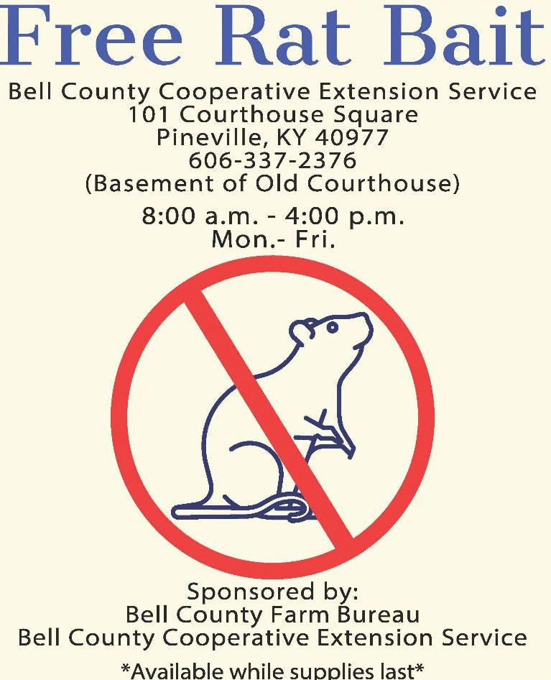

The College of Agriculture, Food and Environment is an Equal Opportunity Organization with respect to education and employment and authorization to provide research, education information and other services only to individuals and institutions that function without regard to economic or social status and will not discriminate on the bases of race, color, ethnic origin, creed, religion, political belief, sex, sexual orientation, gender identity, gender expression, pregnancy, marital status, genetic information, age, veteran status, or physical or mental disability. Inquiries regarding compliance with Title VI and Title VII of the Civil Rights Act of 1964, Title IX of the Educational Amendments, Section 504 of the Rehabilitation Act and other related matter should be directed to Equal Opportunity Office, College of Agriculture, Food and Environment, University of Kentucky, Room S-105, Agriculture Science Building, North Lexington, Kentucky 40546, the UK Office of Institutional Equity and Equal Opportunity, 13 Main Building, University of Kentucky, Lexington, KY 40506-0032 or US Department of Agriculture, Office of the Assistant Secretary for Civil Rights, 1400 Independence Avenue, SW, Washington, D.C. 20250-9410.



extension.ca.uky.edu

AGRICULTURE & NATURAL RESOURCES

**Aaron Redmond**

Bell County Extension Office

Preventing and managing fall pests in your home

As temperatures go down this fall, you may notice more insects around your home. Insects often retreat indoors to escape the cooler temperatures as a part of their overwintering strategy. As pests mistake your home for a heated pile of rocks, you may see hundreds, even thousands, of insects around your home this fall and winter. The most common autumn home invaders you may see are multicolored Asian ladybeetles and the brown marmorated stink bug. Brown marmorated stink bugs tend to be the first invader with the multicolored Asian lady beetle following about a month later. The lady beetle is sometimes called the Halloween beetle for its coloration and the fact that people usually start to notice them in October.

While cooler temperatures have begun, you still have ways to pest-proof your home before pests make their mass exodus to warmer hideaways.

Inspect the exterior of the property and look for gaps in windows and doors, holes in screens, openings in caulk or other sealants and fix them. Without these easy entry points, insects have a tougher time coming inside.

Pesticide applications on the outside of the home may also provide some relief but timing is crucial. When using pesticides, focus on doors, windows, utility openings and banding around the foundation. Make sure to check the label of the pesticide to make sure you can apply it to the necessary areas. Since the primetime for pesticide application has passed, if you see clusters of pests on the exterior of your home, you may also spray them with soapy water to kill them before they start squeezing their way inside. Once the pests have come into your home, it is best to manage them simply by vacuuming or sweeping them up for disposal. Interior pesticide applications are usually unnecessary, especially “bug bomb” type applications which usually don’t reach the hiding spots of overwintering pests.

For more information about pest prevention and management, contact Aaron Redmond, Leslie County Extension Agent for Agriculture and Natural Resources at (606) 672-2154 .

Educational programs of the Cooperative Extension Service serve all people regardless of economic or social status and will not discriminate on the basis of race, color, ethnic origin, national origin, creed, religion, political belief, sex, sexual orientation, gender identity, gender expressions, pregnancy, marital status, genetic information, age, veteran status, or physical or mental disability.

extension.ca.uky.edu

AGRICULTURE & NATURAL RESOURCES

**Aaron Redmond**

Bell County Extension Office

Kentucky Beekeeper Calendar – November & December

*Source:* prepared by Thomas C. Webster Apiculture Extension Specialist

What’s Happening Inside the Hive?

The bees have changed to their wintertime mode. A large colony may have a small amount of brood in early November, but that will soon disappear. By now the queen has completely stopped laying eggs. Five or ten days in November will be warm enough for the bees to fly, but they will find nothing blooming.

As the weather gets cold, the bees form a tight cluster to keep warm. This ball of bees overlaps several frames of honey. The bees gradually consume their stored honey and

generate heat. The colder it gets, the tighter the bee’s cluster. Week by week, the ball of bees gradually moves through the hive to find more honey. When the first snowfall covers the hives, consider that the honeybee is the only insect in Kentucky that keeps warm all winter. In early winter, mice may move into a hive and make a nest. This can occur even if the hive is alive

and well overwinter. The bees are tightly clustered and the mouse finds a spot in the corner away from the bees.

Beekeeper Chores

The year is effectively over. There is now

little to be done for the bees. They will not feed on syrup and it is too late to apply treatments for mites and diseases.

If you haven’t removed your mite treatments and queen excluder, do so on the first warm day in November. Otherwise, there is no reason to

open your hives.

Attach an entrance reducer to the front of

the hive. This serves two purposes: cold wind is kept out of the hive; and, mice are prevented

from nesting in the hive. Entrance reducers may be purchased from beekeeping supply companies. Or, you can simply nail a strip of wood to reduce the opening of the hive. Be sure your entrance reducer is thick enough to be mouse-proof. Some have metal strips to deter mice

Observations and ideas

Late November and December are the best times to plant trees. Black locust and tulip poplar seedlings can be planted where they will provide shade, windbreak, and nectar for the bees. These two trees are known for their rapid growth and copious nectar. As honey plants, trees are a long-term investment. They will not provide significant bloom for several years.

This is a good time to do some reading.

Some fine books and videos are available from beekeeping supply companies. Books on beginning beekeeping, advanced topics such as queen rearing, and general interest are sold.

Beeswax candles are fun and easy to make. They can be rolled from sheets of foundation in minutes. Beeswax foundation comes in dozens of colors, available from beekeeping supply companies.



**PUBLIC LIBRARY**

**JANUARY 19, 2023**

**5:30 PM**

**University of Kentucky** College of Agriculture, Food and Environn1ent

*(-:ooperative Extension Service*

# Crop Pest Management Webinar Series

**2022 University of Kentucky**

**Webinar Series begins in November**

Information regarding your pest management questions is just a few mouse clicks away. As offered in previous years, the University of Kentucky has once again organized five webinars on field crop protection topics that will be hosted

through the Southern Integrated Pest Management Center beginning on Nov. 8, 2022. The weekly webinars will fea­ ture University of Kentucky Extension Specialists speaking on topics ranging from Weed Science, Plant Pathology and Entomology.

Credits have been applied for regarding Kentucky Pesticide Applicator credits and Certified Crop Advisor continuing education. Pre-registration for the webinars is required through the registration URL provided. Dates, speakers and registration links are listed below. All webinars will begin at 10 a.m. EST/ 9 a.m. CST, on the Tuesday morning listed.

For more information contact Jason Travis, Agricultural Extension Associate for the University of Kentucky, at (859) 562

-2569 or by email at [jason.travis@uky.edu.](mailto:jason.travis@uky.edu)

**Webinar#l**

**Date:** November 8, 2022

**Speaker:** Dr. JD Green

**Title:** Weed Control Lessons Learned From the 2022 Crop Season

**Registration URL:** https://zoom.us/webinar/register/WN 4JQovXYvR76A2Xp tSmBwg

**Webinar#2**

**Date:** November 15, 2022

**Speaker:** Dr. Carl Bradley

**Title:** Managing Important Soilborne Diseases of Soybean in Kentucky

**Registration URL:** https://zoom.us/webinar/register/WN t6D6toO8Sh2BhyoD3iwlHQ

**Webinar#3**

**Date:** November 22, 2022

**Speaker:** Dr. Travis Legleiter

**Title:** Implementing Defensive Shifts Against Problematic Kentucky Weeds

**Registration URL:** https://zoom.us/webinar/register/WN QnugWPJJQUynBXDf4io9zg

**Webinar#4**

**Date:** December 6, 2022

**Speaker:** Dr. Kiersten **A.** Wise

**Title:** Corn Disease Management Questions Asked in 2022

**Registration** URL: https://zoom.us/webinar/register/WN KwibLTsHQY6oJjiKzURCEQ

**Webinar#S**



**Date:** December 13, 2022

**Speaker:** Dr. Raul Villanueva

**Title:** Entomological Studies in Corn and Soybeans Under Difficult Circumstances (Covid, a Tornado and Drought) in 2022

**University of Kentucky**

;tt., ; ;

***CooJ)tl'ativt£xtffldon*Stnoict'**

***A,rkulttut andNatural Hno&ltta***

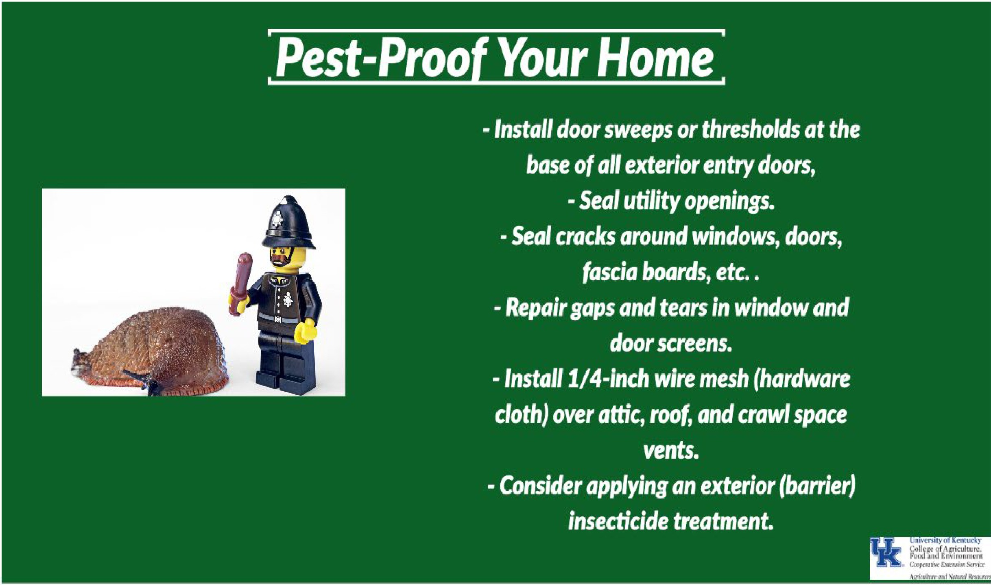

Bell County Cooperative Extension

101 Courthouse Square

Pineville, KY 40977

(606)337-2376

RooTSToCK

APPLE AND PEAR FoR GRAFTING

Univcrs.ity of Kentucky

Colk-gc oF Agriculture,

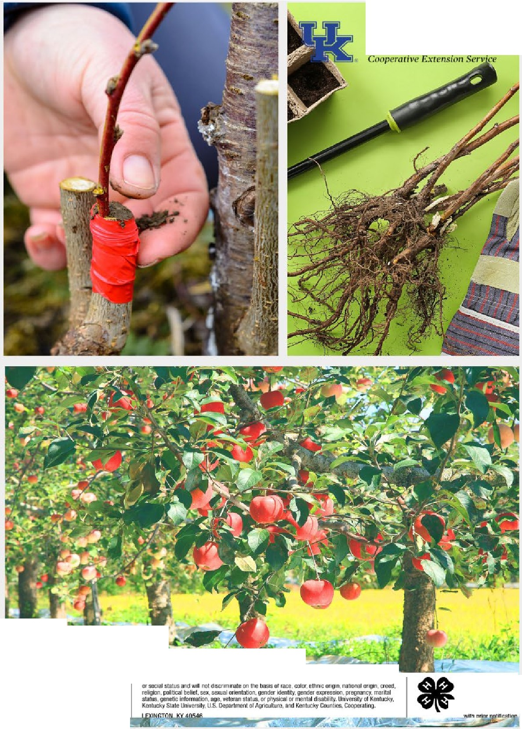

Food anJ Environment

##### ORDERS BEGIN JAN. 3, 2023

-UMITED SUPPLY-

PRE-PAY ONLY CALL 337-2376 FoR QUESTIONS

##### RooTSToCK WoRKSHoP MARCH 14, 2023 6:00 P.M. --·­

REGlSTRATloN REQUIRED - -= =--·-- IE.i&.,I

4 H Yrulh Developmool !7 =G

'

llh!td

## Venison Stew

Servings:6 Serving Size:2 cups

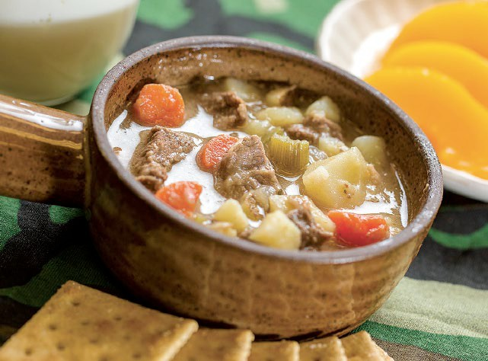

###### Ingredients:

* ½ teaspoon black pepper
* 1 teaspoon salt
* ½ teaspoon garlic powder
* 2 tablespoons flour
* 1 pound venison, cubed
* 1 tablespoon oil
* 3 cups water
* 1 onion, chopped
* 4 potatoes, cubed
* 3 carrots, sliced
* 3 stalks celery, chopped
* 2 bay leaves
* 1 tablespoon dried parsley

###### Directions:

Combine pepper, salt, garlic powder, and flour in a plastic bag or large bowl. Add cubed venison and shake bag or toss to coat meat. Brown meat in hot oil, in a large, heavy saucepan. Stir in water. Add remaining ingredients and cook on high until it begins to boil. Reduce heat and simmer for approximately 1 hour. To thicken, in a small mixing bowl, stir ½ cup warm water into 2 tablespoons of flour. Add mixture into stew. Stir until thickened and bubbly. Cook an additional 30 minutes or until vegetables and meat are tender.

Source: Adapted from Venison Recipe Collection, Compiled by Becky Nash, Extension Agent for Family and Consumer Sciences

###### Tips

Alternative to stove-top cooking: use slow cooker set on low for 8 hours.

Nutrition facts per serving: 270 calories; 4.5g total fat; 1g saturated fat; 0g trans fat; 65mg cholesterol; 490mg sodium; 36g carbohydrate; 5g fiber; 5g sugars; 22g protein; 0% Daily Value of Vitamin D; 6% Daily Value of Calcium; 20% Daily Value of Iron; 25% Daily value of Potassium

Bell County 4-H News

###### December 2022/January 2023

**Cooperative Extension Service**

Bell County

101 Courthouse Square

Pineville, Kentucky 40977-1635

(606) 337-2376

Fax: (606) 337-6739

extension.ca.uky.edu

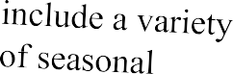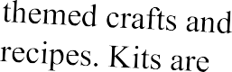

**4-H Grab and Go Bags**

**4-H Country Ham Project**

It is time to begin the Kentucky 4-H Country Ham Project.

Last year six participants competed at the Kentucky State Fair. We had two students place second and third in the state with their speech demonstrations!

This project is an enjoyable program that teaches youth, ages 9-18, valuable life skills. If you are interested in having a child in your life participate, please contact our office at 606-337-2376 to obtain a contract. We will continue taking contracts until 12/09/2022.

**4-H Club News**



Bell County 4-H currently has four clubs that youth can participate in!

Middlesboro 4-H Club at Southeast Community and Technical College Bell County 4-H Club at Bell Whitley Community Action Agency

These clubs are open to any youth, ages 9-18. STEM projects, leadership, and natural resource lessons are included.

Bell County Cloverbuds Club at Old Bell County Courthouse

This club is open to any youth ages 5-8. Lessons on everyday skills, local first responders, and engaging activities are included.

For information about these clubs, please contact our office at 606-337-2376 Middlesboro Cloverbuds at Middlesboro Elementary

All clubs meet once a month.



**UP**

4-H

**MIDDLESBOR04-H**

### @SKCTC AGES 9-18

3:30-4:30

#### 12/13

&1/17

**BELL COUNTY 4-H COMMUNITY CLUB** @ BELL WHITLEY

AGES 9-18 3:30-4:30

### 12/8 & 1/19

**CLOVERBUDS**

***4-H* CLUB**

@ Bell County

Court House

### 01 /23 6:00-7:00

#### AGES 5-8

**CounhyHam**

**Proied**

ages 9-18

contracts 1219

**FUTURE GRAB BAGS**

12/14

4-H AGENT BRIAN GOOD

606-337-2376

due





Bell County

University of Kentucky College of Agi:iculture, Food and Environmen

*Cooperative Extension* Sen•ice

NONPROFIT ORG US POSTAGE PAID

Pineville, KY PERMIT77

101 Courthouse Square

Pineville, KY 40977-1635

RETURN SERVICE REQUESTED

**Rebecca Miller**



**For more information about the Bell County Cooperative Extension Service:**

**Visit our website at:** [**http://bell.ca.uky.edu/**](http://bell.ca.uky.edu/)

Follow us on Facebook at Bell County Cooperative Extension Service

**Bell County Extension Agent Family and Consumer Sciences**

*�eeQ ��*

**Brian Good**

**Bell County Extension Agent 4-H Youth Development**

**Aaron Redmond**

**Bell County Extension Agent Agriculture and Natural Resources**



**Cooperative Extension Service** Agriculture and Natural Resources Family and Consumer Sciences

**4-H** Youth Development

Community and Economic Development

Educational programs of Kentucky Cooperative Extension serve an people regardless of economic

or social status and will not discriminate on the basis of race, color, ethnic origin, national origin, crew, religion, political belief, sex, sexual orientation, gender Identity, gender expression, pregnancy, marital status, genetic Information, age, veteran stabJs, or physical or mental disability. University of Kentucky, Kentucky Stale University, U.S. Department of Agriculture, and Kentucky Counties, Cooperating.

LEXINGTON, KY 40546

•· lltles

accommodated

with prior no!Hicalion.